(Approx. 399 words)

How To Send An Email Message To Any Cell Phone
Written by Ken Peters, Product Review / Special Interests, Hilton Head Island Computer Club, SC
www.hhicc.org
product.review (at) hhicc.org

This article has been obtained from APCUG with the author’s permission for publication by APCUG member groups; all other uses require the permission of the author (see e-mail address above).

Impress your kids, grandkids and friends with your ability to text. Send a text message to their cell phone by email from your computer.

Most cell phones have the ability to send and receive short text messages. This is called short message service (SMS) or text paging. This service can take email
sent over the internet and deliver them to a cell phone as a text message. Each carrier has its own email address extension i.e. @tmomail.net for T Mobile carrier.

The two things you need to know to send a message are the person’s cell phone number and their carrier’s email extension. So to send to a T Mobile phone, enter the phone number and add the extension - 8433216549@tmomail.net

The message will look similar to this.

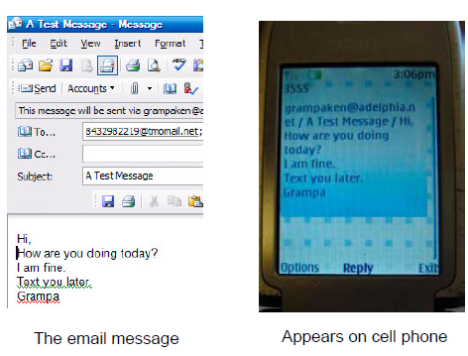

Some of the common cell phone emails are:
Alltel AT&T (formerly Cingular)
10-digit phone number@message.alltel.com 10-digit phone number@txt.att.net
Example: 2125551212@message.alltel.com Example: 2125551212@txt.att.net

Boost Mobile Nextel (now part of Sprint Nextel)
10-digit phone number@myboostmobile.com 10-digit telephone number@messag
Example: 2125551212@myboostmobile.com ing.nextel.com
Example: 7035551234@messaging.
nextel.com

T-Mobile Verizon
10-digit phone number@tmomail.net 10-digit phone number@vtext.com
Example: 4251234567@tmomail.net Example: 5552223333@vtext.com

Virgin Mobile USA US Cellular
10-digit phone number@vmobl.com 10digitphonenumber@email.uscc.net
Example: 2622341256r@vmobl.com Example: 2125551212@ email.uscc.net

Sprint PCS (now Sprint Nextel)
10-digit phone number@messaging.sprintpcs.com
Example: 2125551234@messaging.sprintpcs.com

If you can’t find the email address for the carrier, check the carrier’s website (Links above) or call their customer service.

The one receiving the message may be charged 10 to 15 cents per message unless they have a plan that includes text messaging. Your kids and grandkids most probably do have a text plan. There is a 160 character limit per message including the email address and the subject line. Some carriers will split the message into two messages if it is longer.

The person receiving the email text message can reply to you from their phone and sometime later you’ll receive their reply in your email inbox. If you don’t like texting from a cell phone or hate trying to type a message with those small phone keys, give this a try. It’s fun.

